# MINI PROJECT (2020-21)

**Instagram Clone**

**MID-TERM REPORT**



**Institute of Engineering & Technology**

**Submitted by-**

# Kritarth Sharma (181500335)

# Priyanka Nigam (181500509)

***Supervised***

***By: -* Mr. Amir Khan**

Technical Trainer

# Department of Computer Engineering & Applications

**Contents**

|  |  |  |  |
| --- | --- | --- | --- |
| **1.Abstract** | | **3** | |
| **2. Features** | | **4** | |
| **3. Objectives** | | **35** | |
| **4.Software and Hardware Requirements**  **5**. **Technology Used**  **6. Certificates**  **7. References** | | **37**  **38**  **52**  **57** | |
|  | |  | |
|  | |  | |
|  | |  | |
|  | |  | |

**Abstract**

In this we will build a a dynamic project siimilar to instagram that has innovative features. We are trying to add as many features as possible.

A mobile photo(and video) capturing and sharing service, has quickly emerged as a new medium in spotlight in the recent years. It provides users an instantaneous way to capture and share their life moments with friendsthrough a series of (ﬁlter manipulated) pictures and videos.

**Features**

**1)Login User**

User can login we have used django authentication system for logging in users.Also a demo account is given for making it more useful for project purposes.

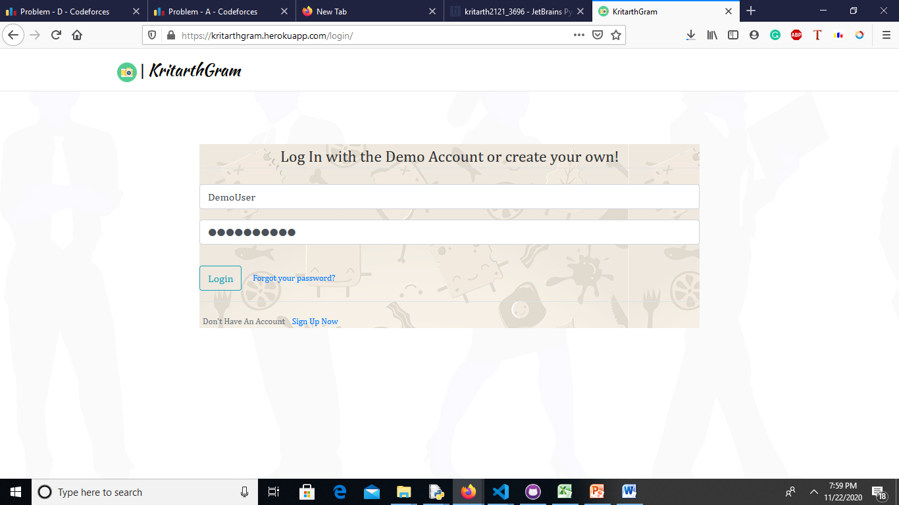

**2)Adding Posts**

Users can add post,(Upto post at a time).These post are saved in amazon s3 bucket.We have usesd AWS here.

We can also add caption for image here

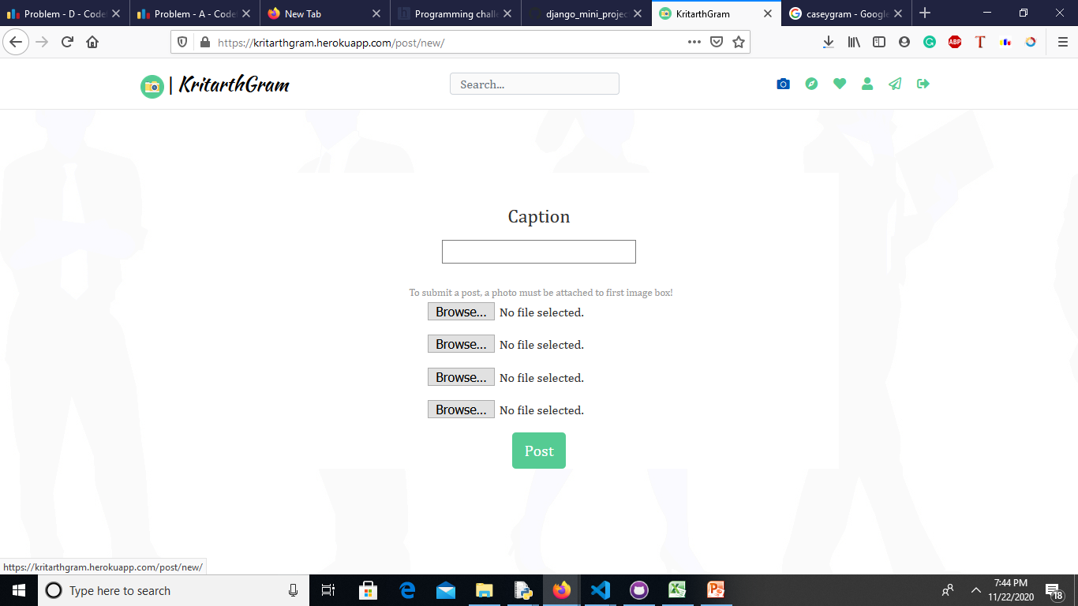

**3)Creating Account**

Users can create account by filling their credentials like desired username,emailid,password.We have used regex for password validation and username validation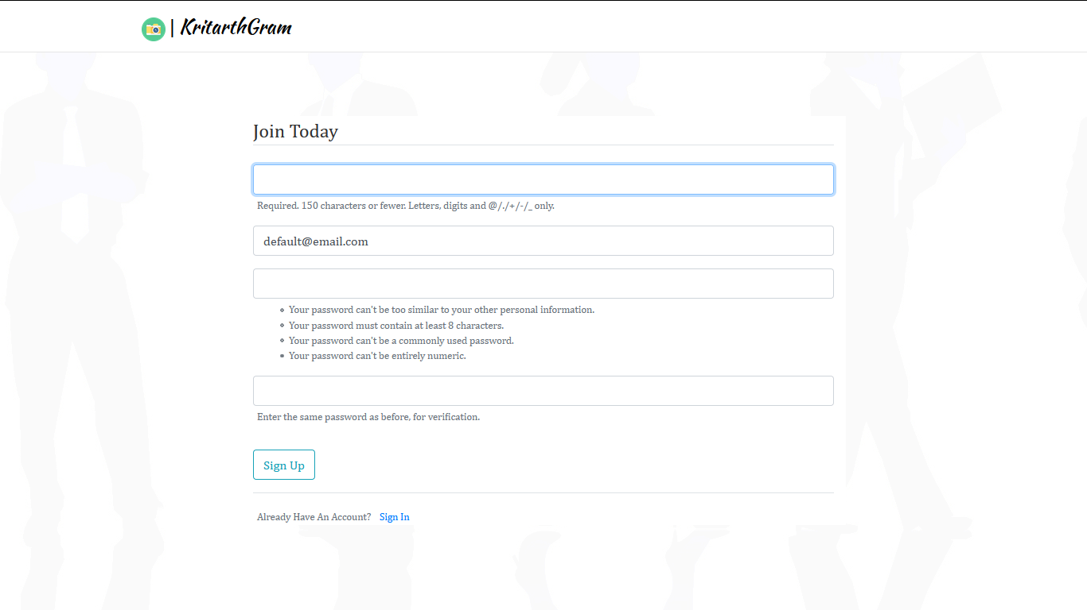

,If password doesn’t matches desired regex sequence then a, error is thrown

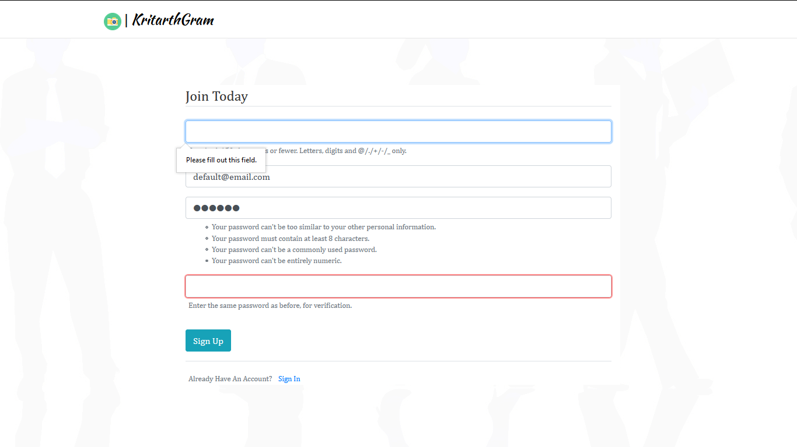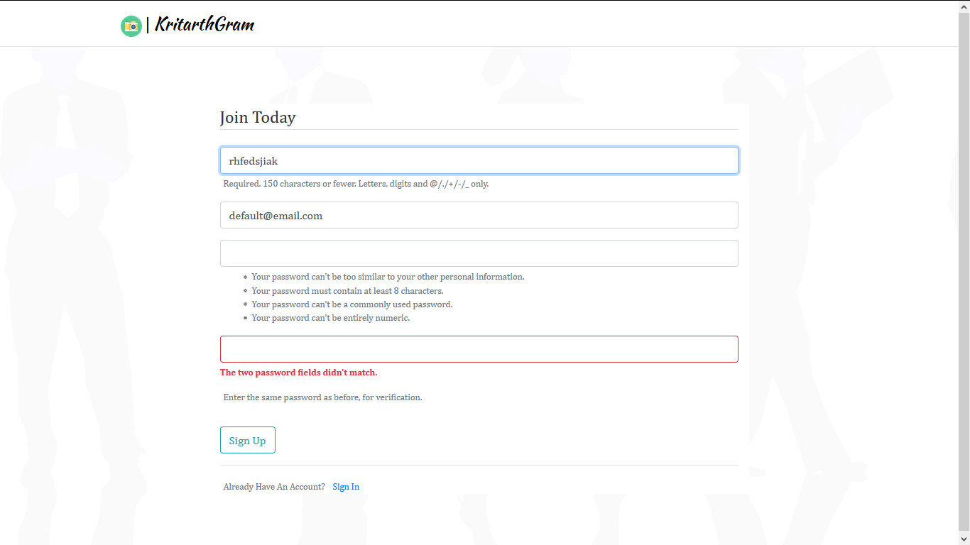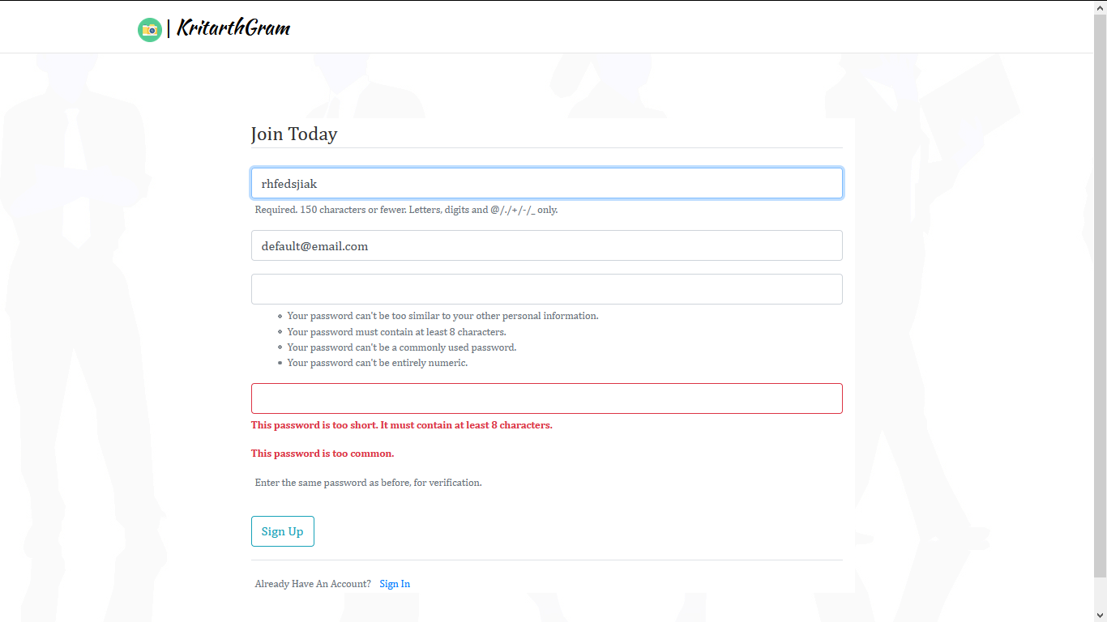

**3)Feed**

Posts are displayed along with their like count and comments.One user can like the post only once,but a user can comment multiple times on the post.

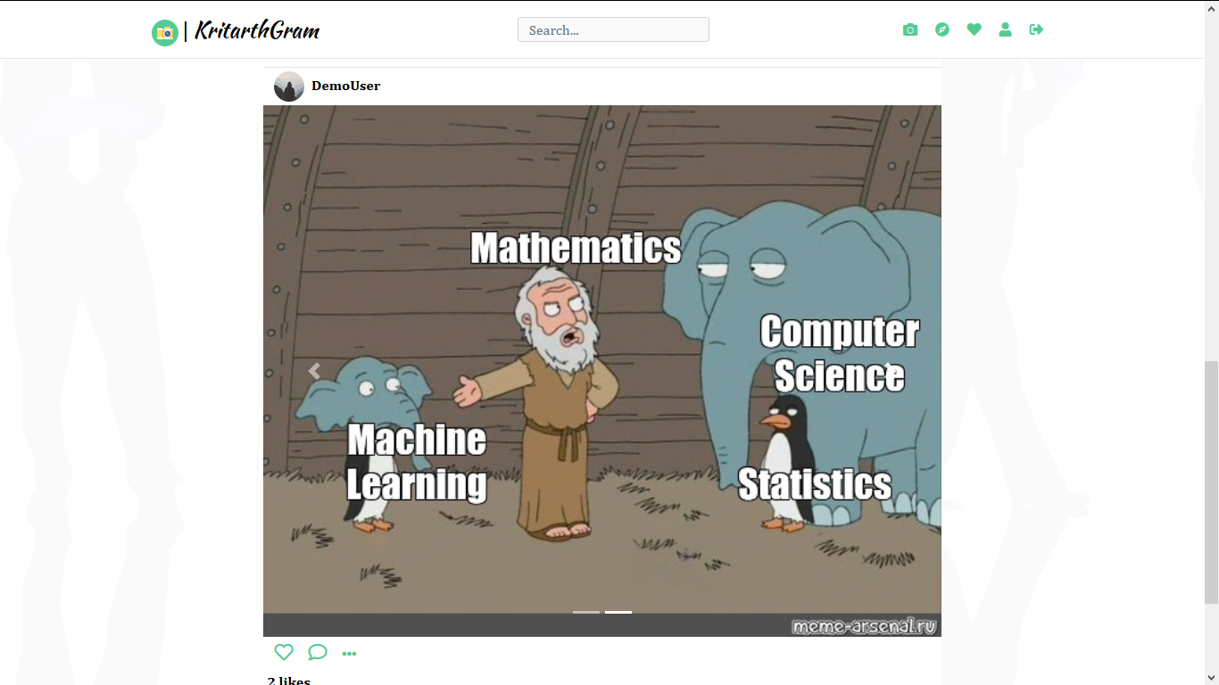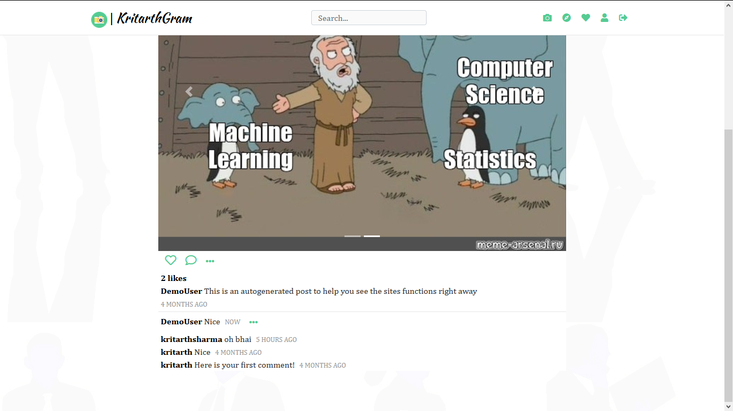

**4)Like**

Users can like on the post,without refreshing of the page the like is stored instantaneously using ajax request.

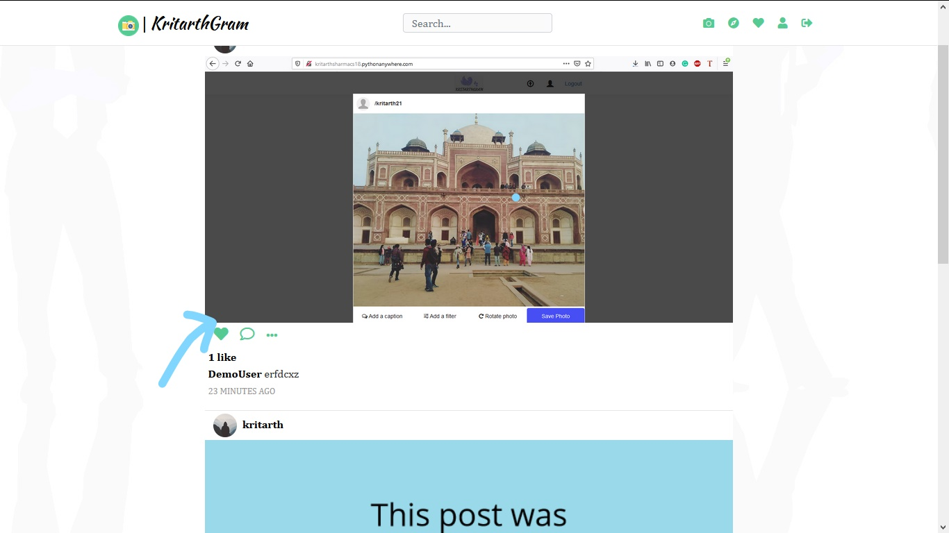

**5)Comment**

Users can comment any no of time on any post

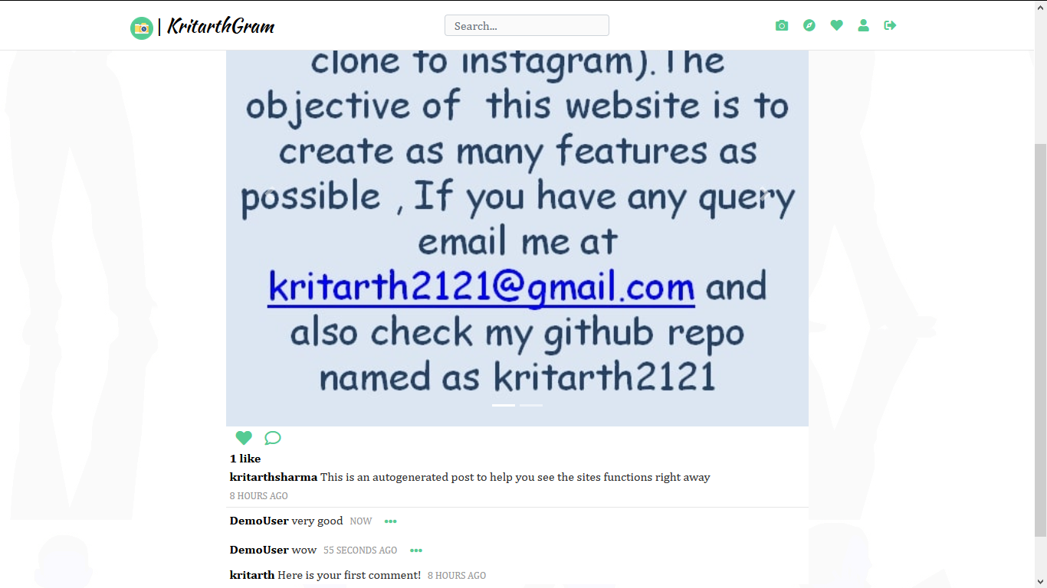

**6)Search**

We can search for any text present in any username,any post.

The search results are then fetched in list order.

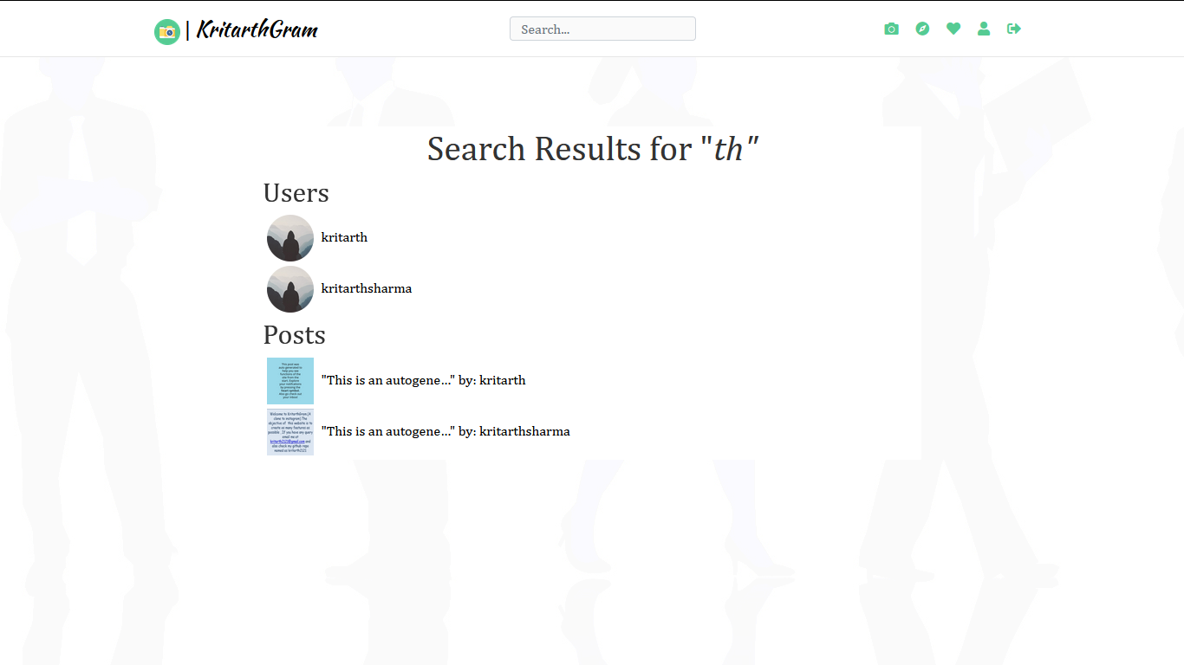

**7)Explore**

There is a feature of exploring newly made accounts,newly made posts

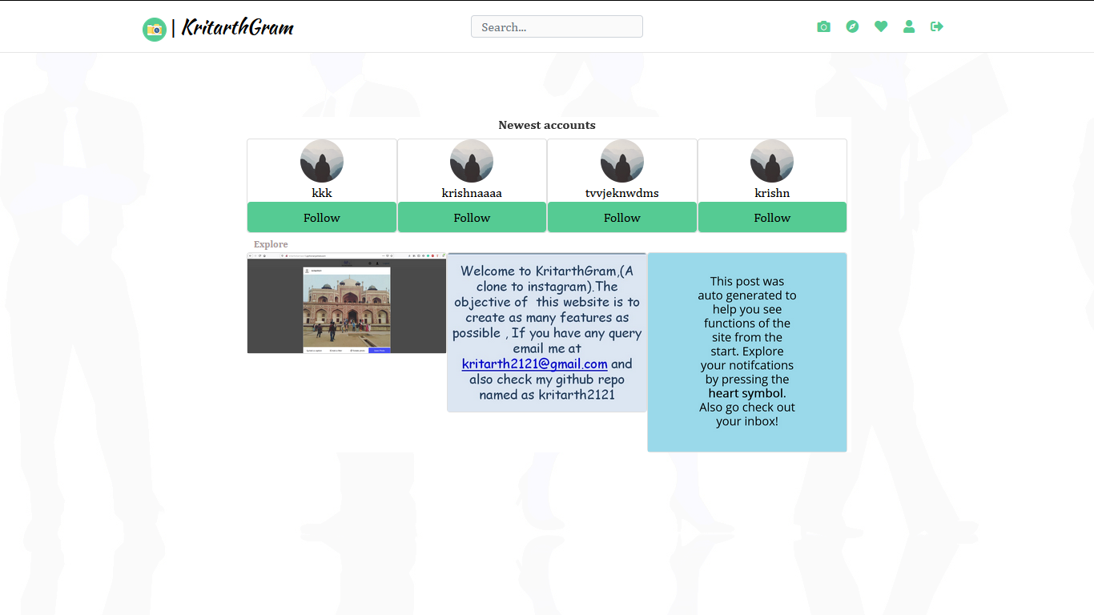

**8)Notification**

Here user can view who have liked ,commented or followed them.

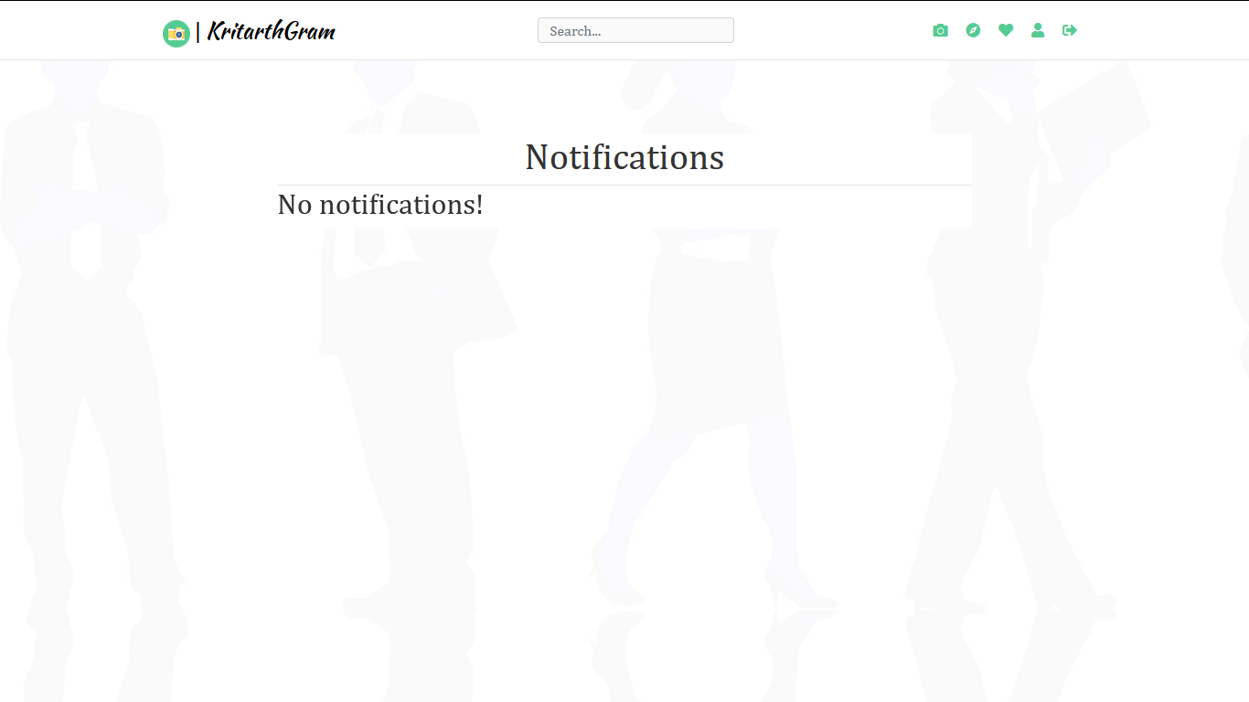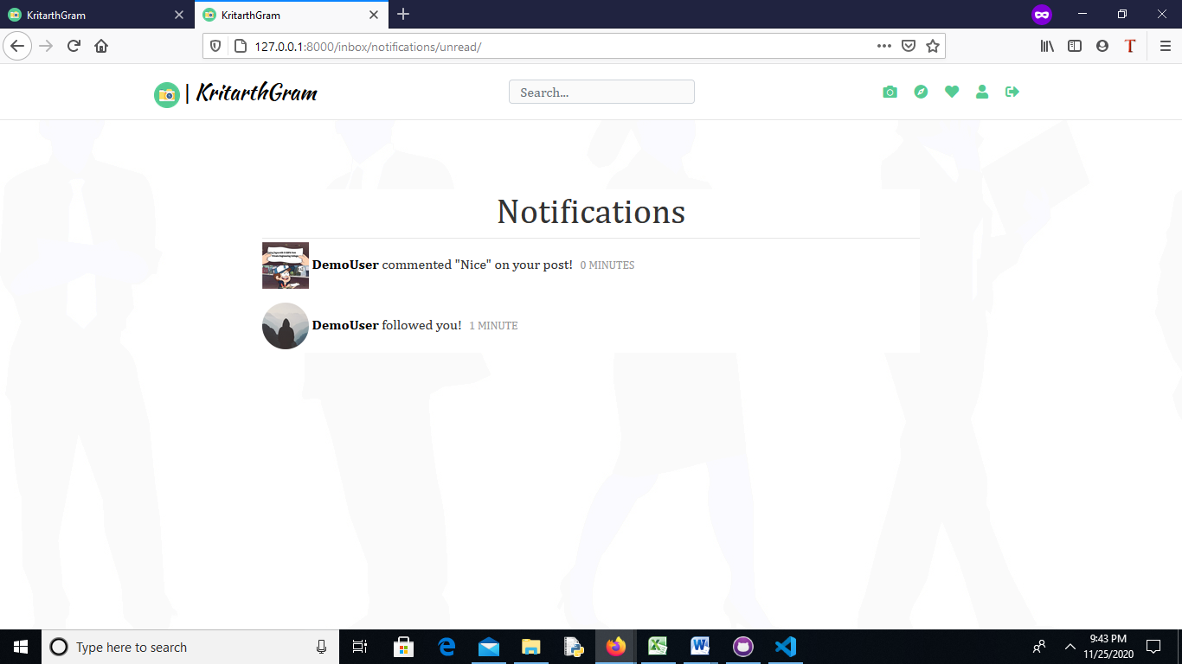

**9)Profile view.**

Users can see their followers ,following list,photos,.They can also edit their profile picture and update and delete any posts.

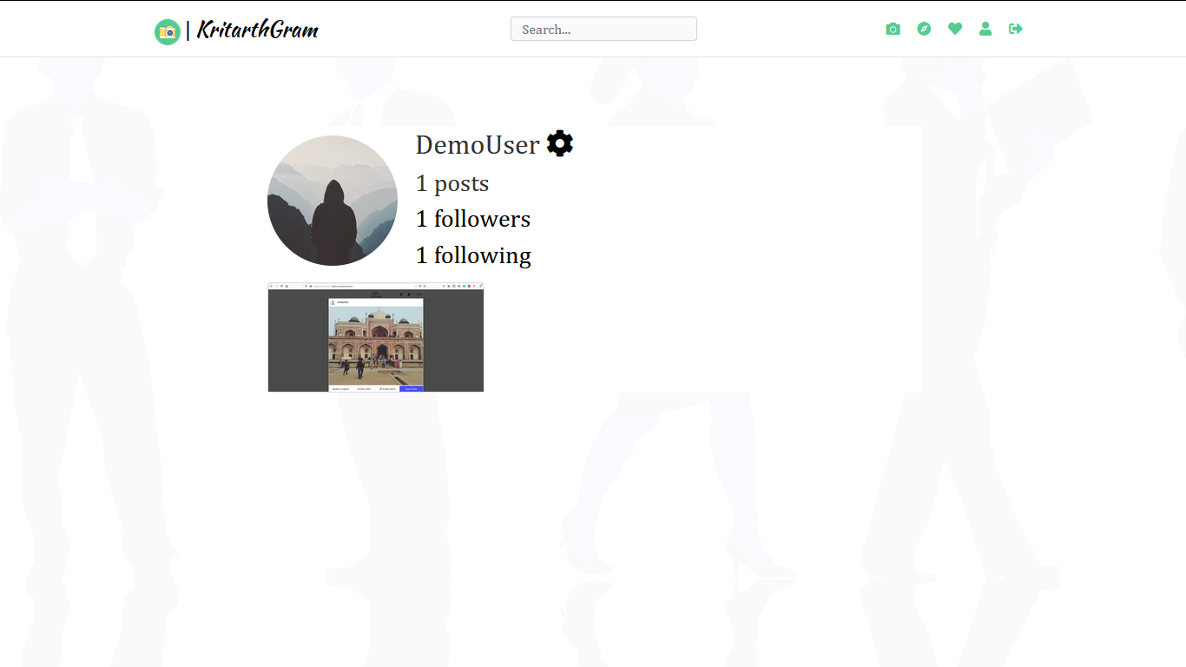

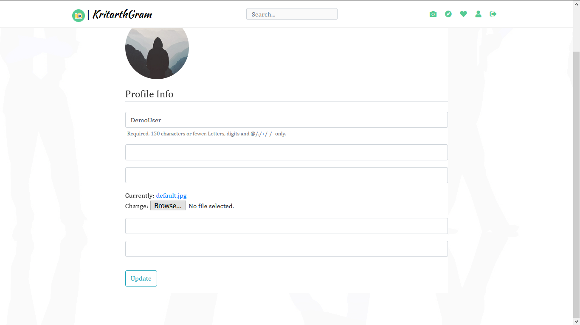

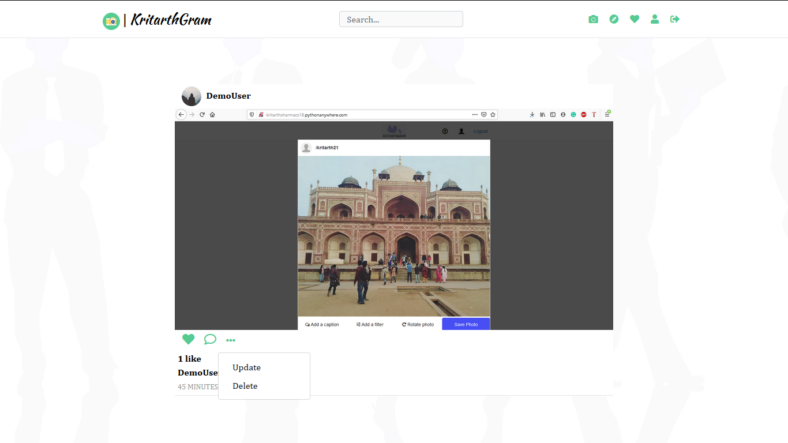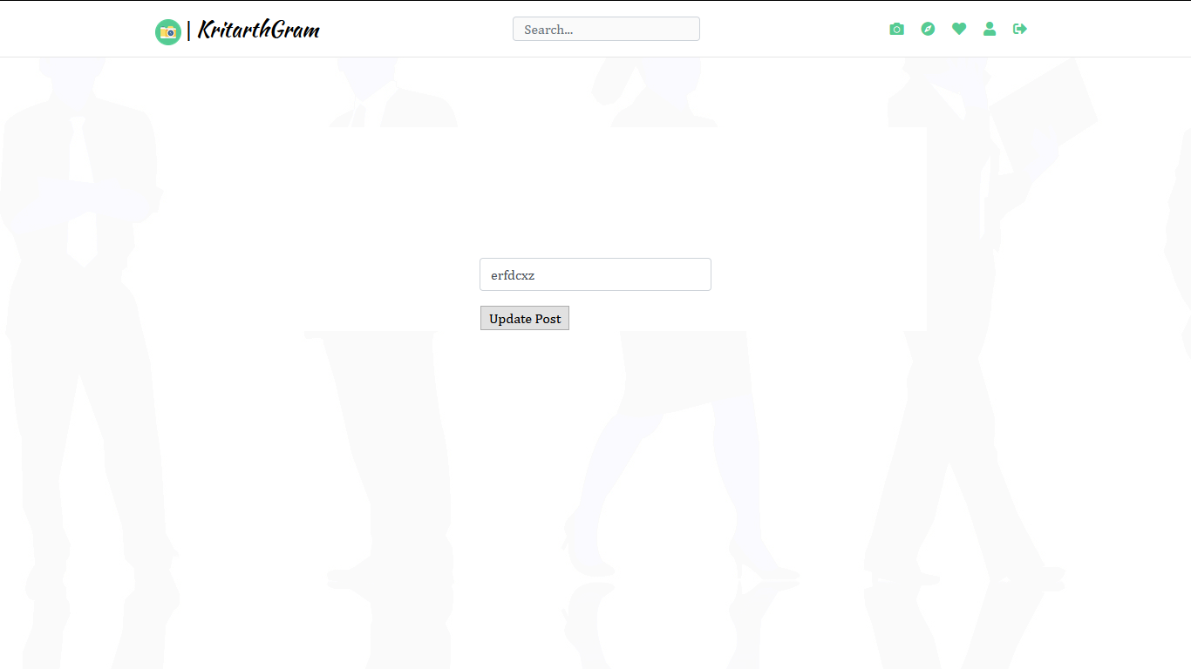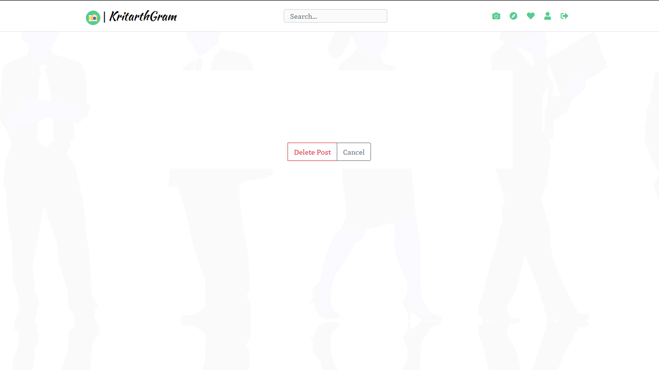

**10)Adding posts**

We can add post along with caption,we can add 4 photos at a time.

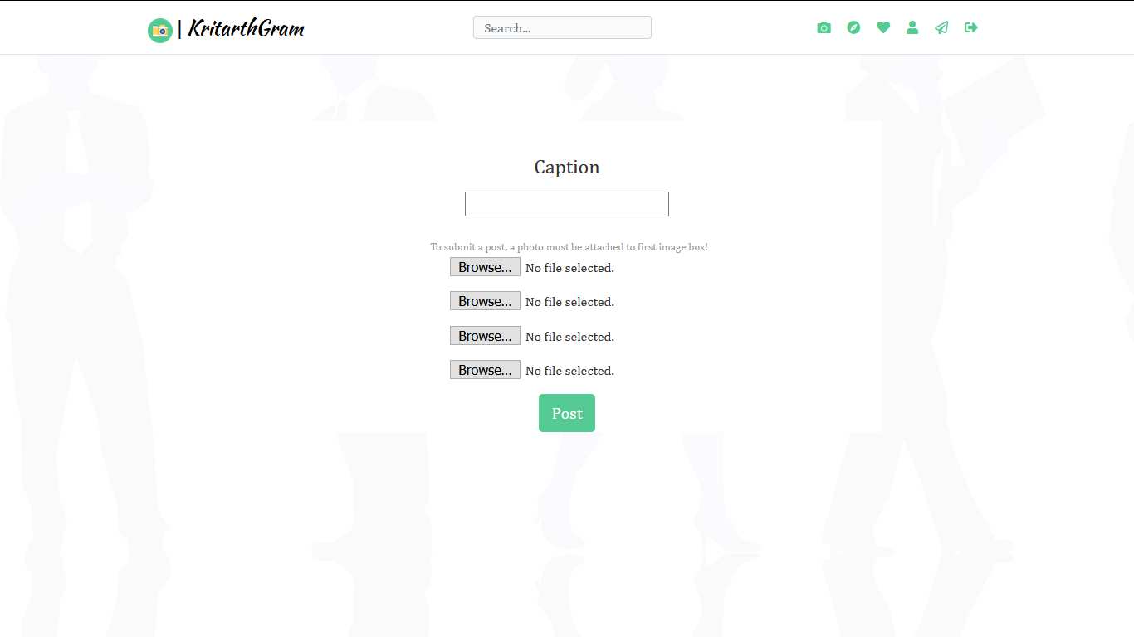

**11)Logout**

Users can logout from their account simply by clicking on the logout icon present on the corner of page.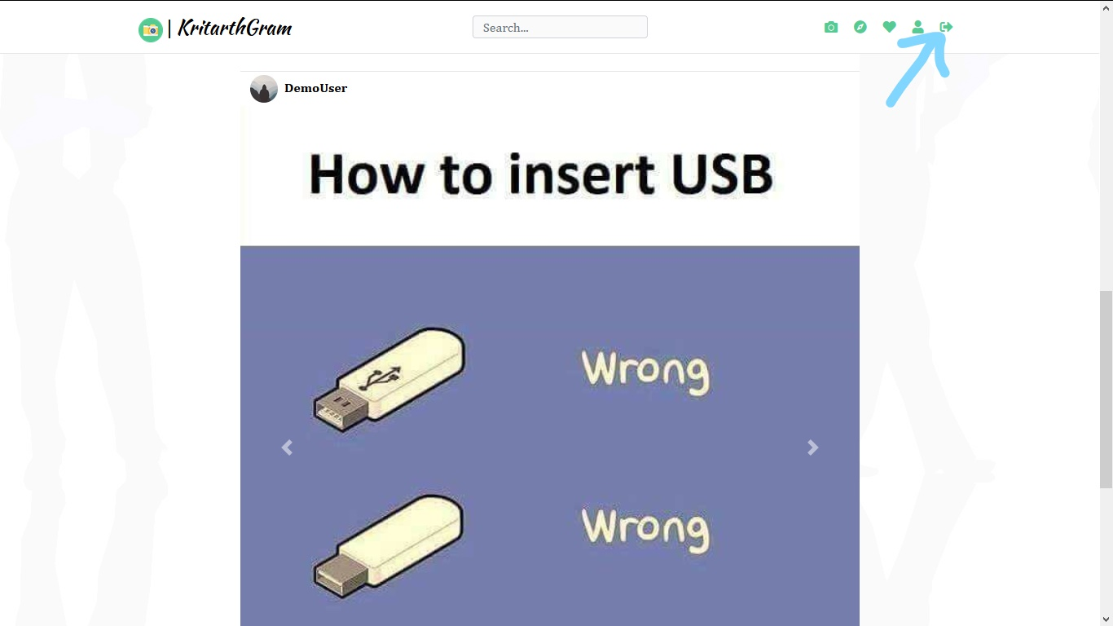

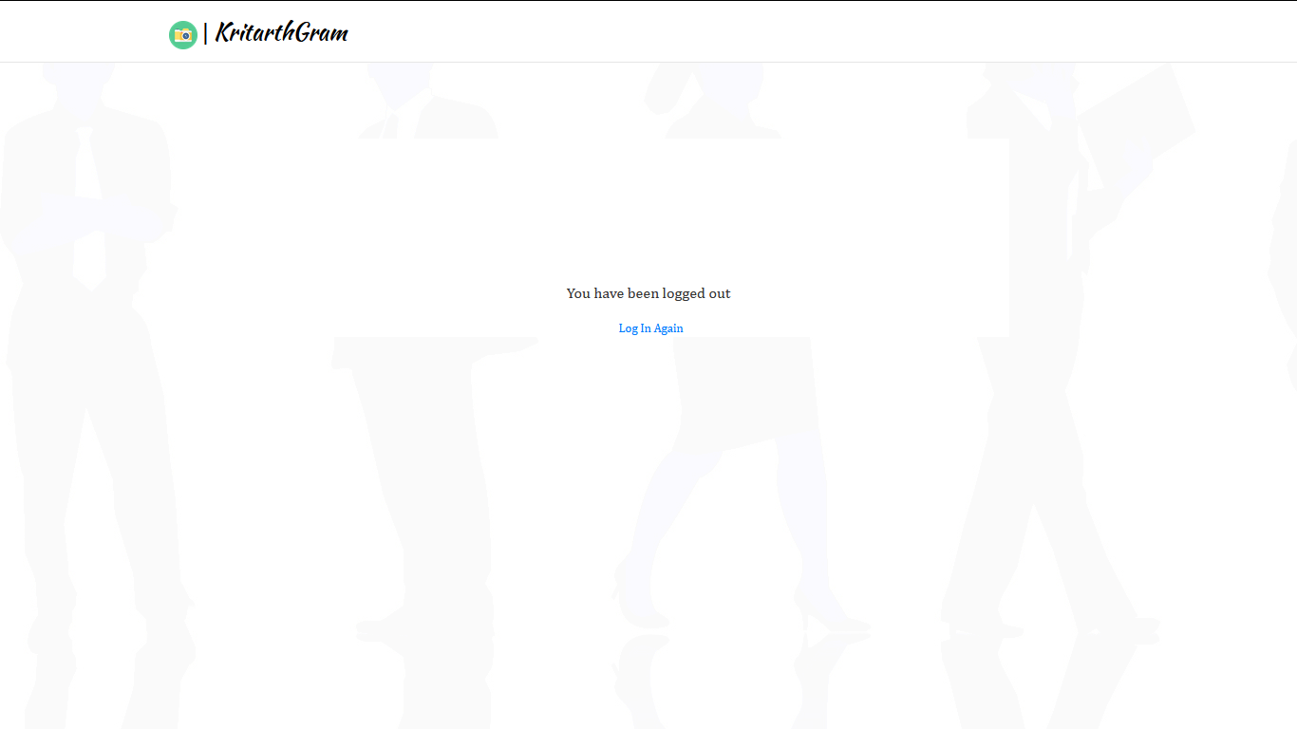

**12)Amazon s3 for storage**

We have used amazon s3 for storing media.

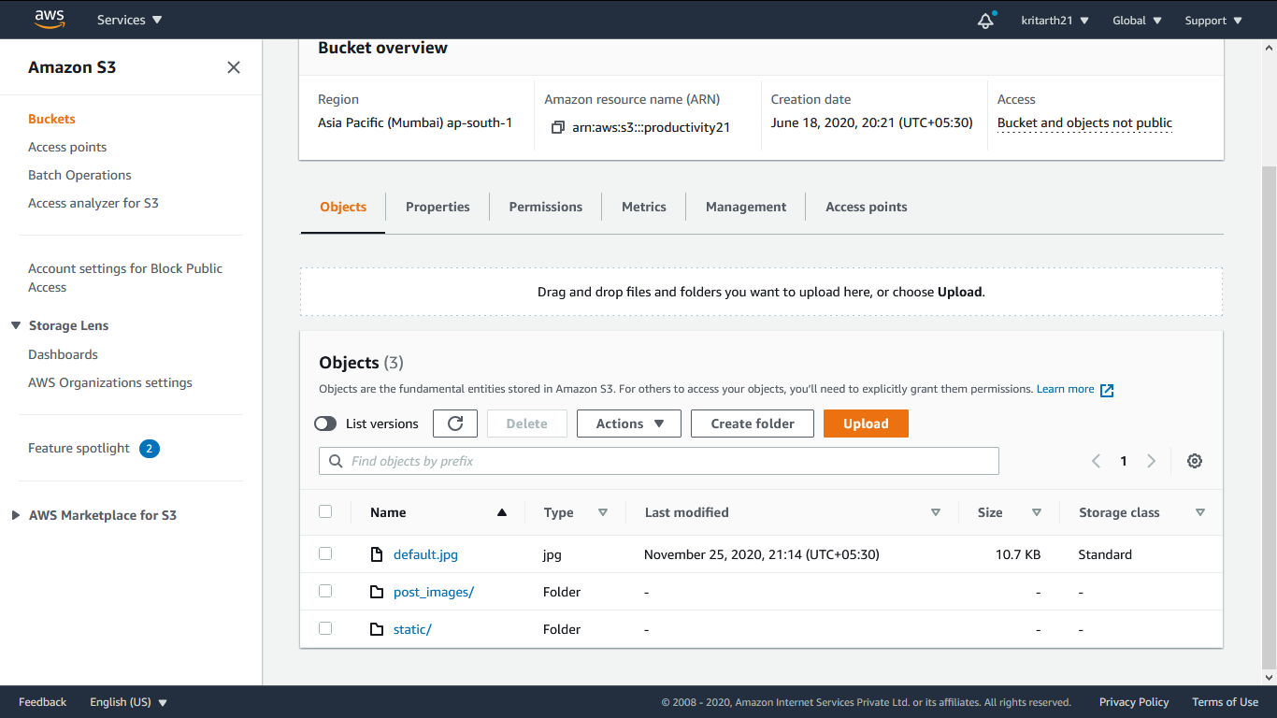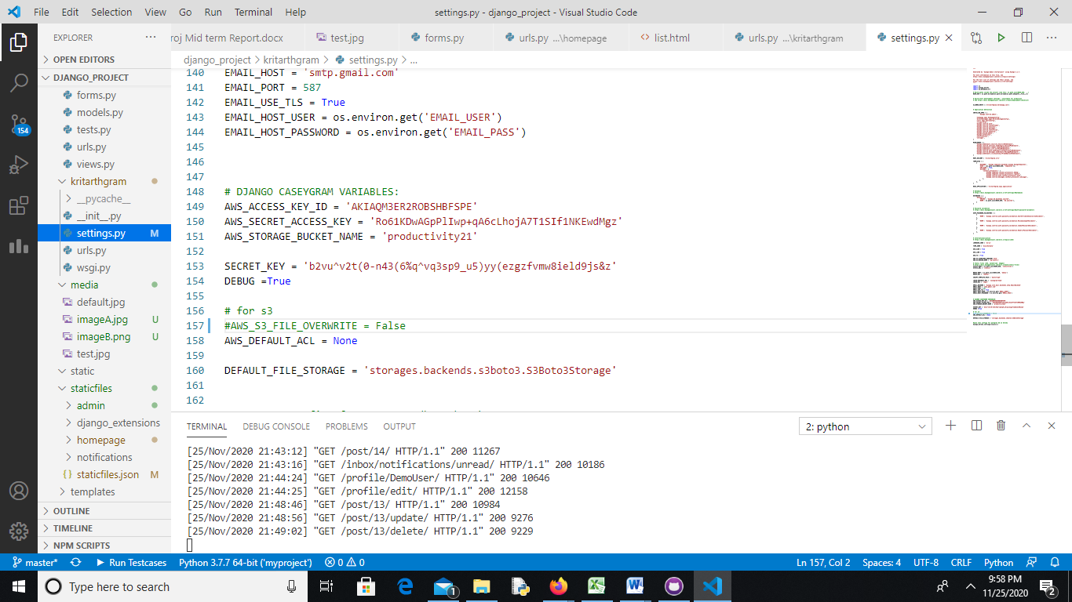

**13)Responsiveness**

We have made it fully respnsive

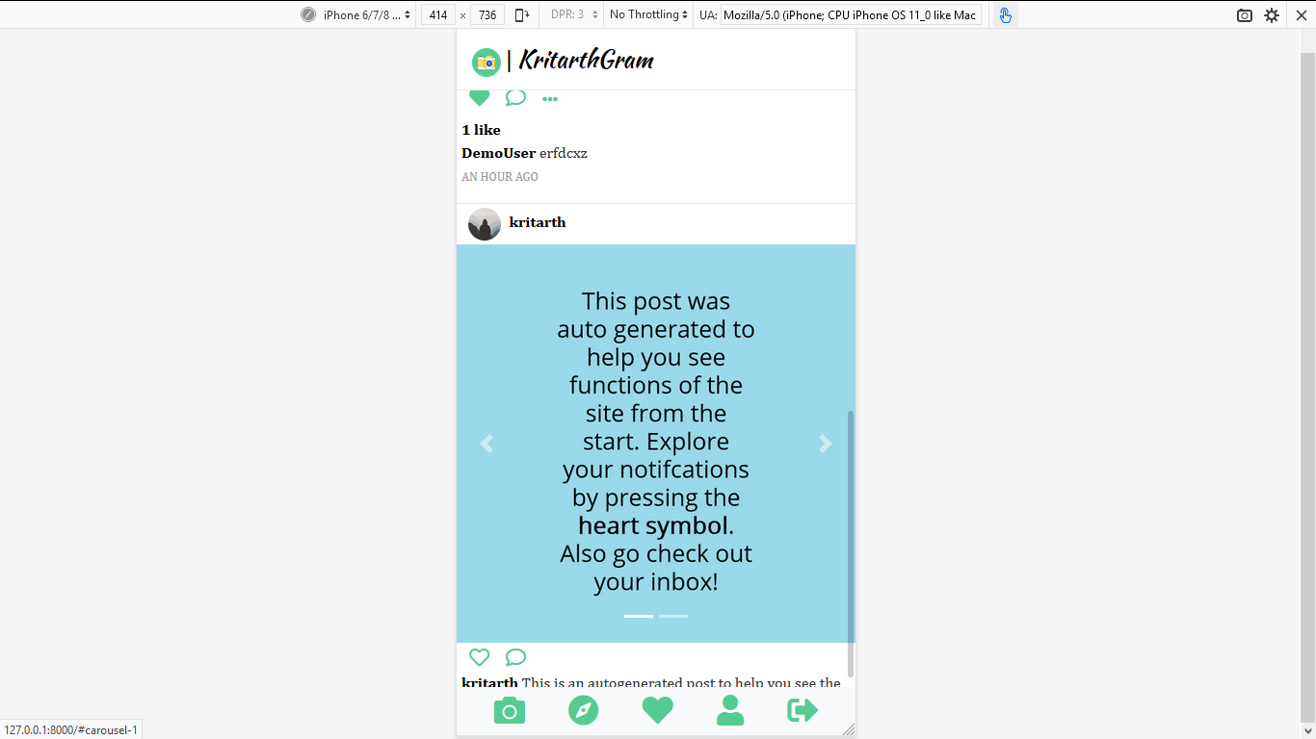

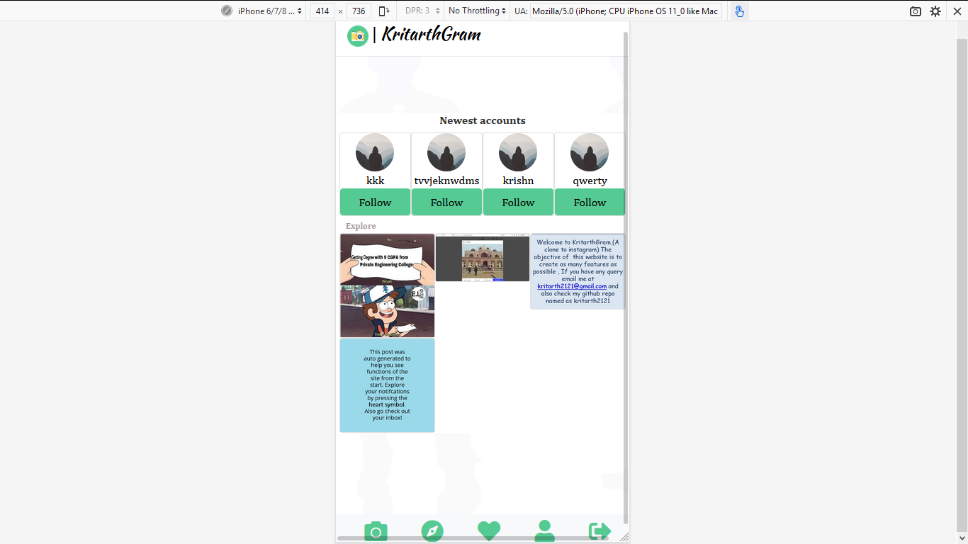

**14)Database**

We have used django default database sqllite,as datbase

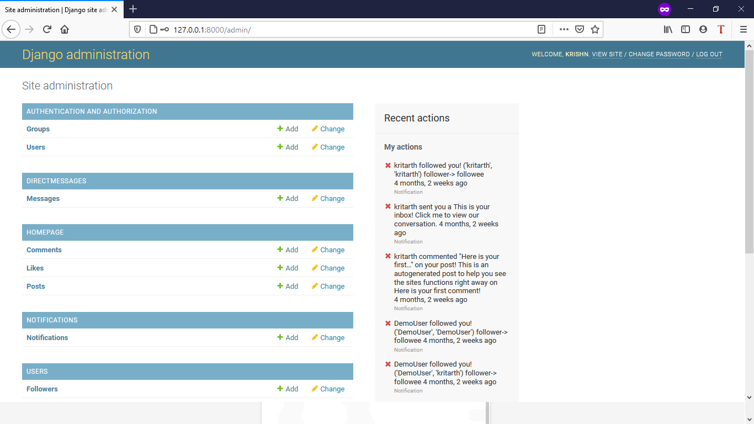

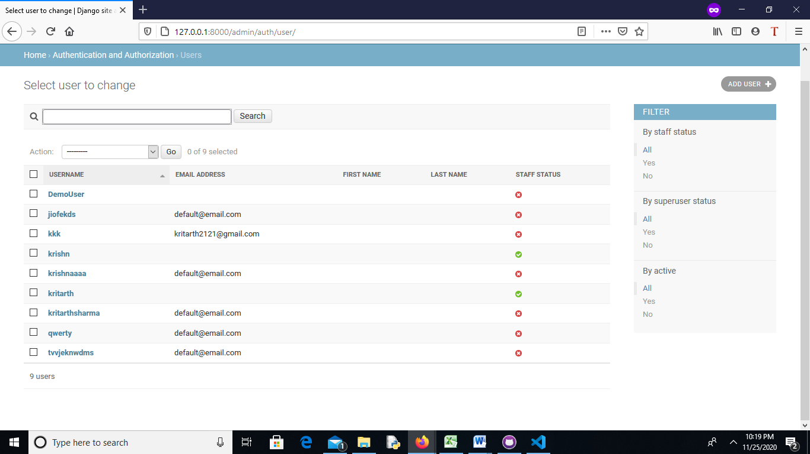

**15)Hosting**

The site is hosted on heroku,at <https://kritarthgram.herokuapp.com/>

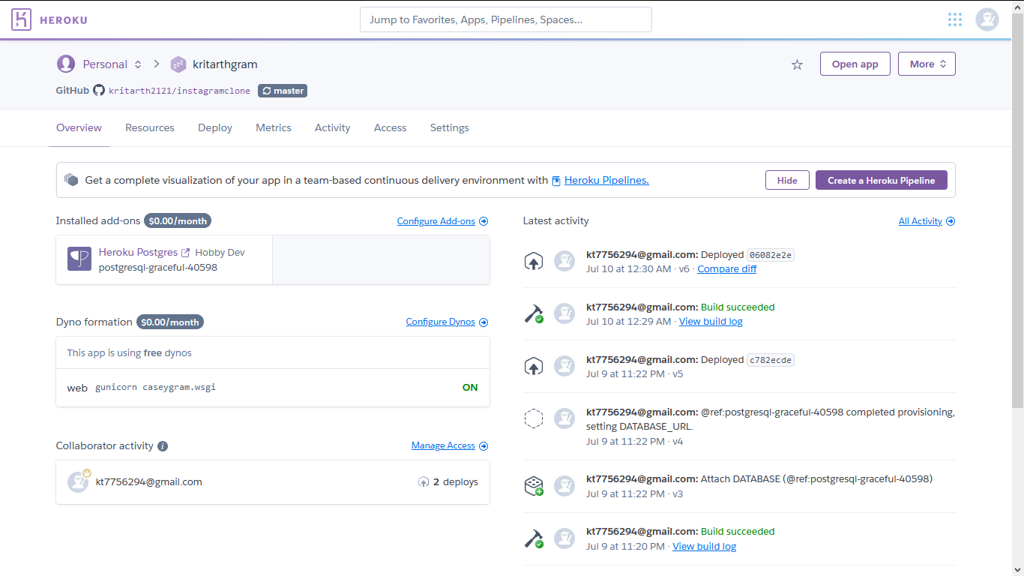

# Objective

The main objectives of Social networking project is to make people connected as much as possible.

Here people can upload photos or videos to our service and share them with their followers or with a select group of friends. They can also view, comment and like posts shared by their friends on **Kritarthgram**.

As social networking sites are gaining popularity day by day,so we try to build it using Django,Ajax,HTML,CSS,Javascript,Amazon s3

It is an Indian based web-app hosted on Heroku.

**Software Specification:**

Technology Implemented : Django

Language Used : Python

Database : Mysql

User Interface Design : Html,CSS , javascript and Bootstrap

Web Browser : Microsoft edge/chrome

**Hardware Requirements:**

Processor : 64-bit/32 bit

Operating System : Any one (Preferrrably above Windows 8)

RAM : 4-GB

**Technology Used**

**HTML**

**Hypertext Markup Language** (**HTML**) is the standard [markup language](https://en.wikipedia.org/wiki/Markup_language) for documents designed to be displayed in a [web browser](https://en.wikipedia.org/wiki/Web_browser). It can be assisted by technologies such as [Cascading Style Sheets](https://en.wikipedia.org/wiki/Cascading_Style_Sheets) (CSS) and [scripting languages](https://en.wikipedia.org/wiki/Scripting_language) such as [JavaScript](https://en.wikipedia.org/wiki/JavaScript).

[Web browsers](https://en.wikipedia.org/wiki/Web_browser) receive HTML documents from a [web server](https://en.wikipedia.org/wiki/Web_server) or from local storage and [render](https://en.wikipedia.org/wiki/Browser_engine) the documents into multimedia web pages. HTML describes the structure of a [web page](https://en.wikipedia.org/wiki/Web_page) [semantically](https://en.wikipedia.org/wiki/Semantic_Web) and originally included cues for the appearance of the document.

[HTML elements](https://en.wikipedia.org/wiki/HTML_element) are the building blocks of HTML pages. With HTML constructs, [images](https://en.wikipedia.org/wiki/HTML_element#Images_and_objects) and other objects such as [interactive forms](https://en.wikipedia.org/wiki/Fieldset) may be embedded into the rendered page. HTML provides a means to create [structured documents](https://en.wikipedia.org/wiki/Structured_document) by denoting structural [semantics](https://en.wikipedia.org/wiki/Semantics) for text such as headings, paragraphs, lists, [links](https://en.wikipedia.org/wiki/Hyperlink), quotes and other items. HTML elements are delineated by *tags*, written using [angle brackets](https://en.wikipedia.org/wiki/Bracket#Angle_brackets). Tags such as <img /> and <input /> directly introduce content into the page. Other tags such as <p> surround and provide information about document text and may include other tags as sub-elements. Browsers do not display the HTML tags, but use them to interpret the content of the page.

HTML can embed programs written in a [scripting language](https://en.wikipedia.org/wiki/Scripting_language) such as [JavaScript](https://en.wikipedia.org/wiki/JavaScript), which affects the behavior and content of web pages. Inclusion of CSS defines the look and layout of content. The [World Wide Web Consortium](https://en.wikipedia.org/wiki/World_Wide_Web_Consortium) (W3C), former maintainer of the HTML and current maintainer of the CSS standards, has encouraged the use of CSS over explicit presentational HTML since 1997

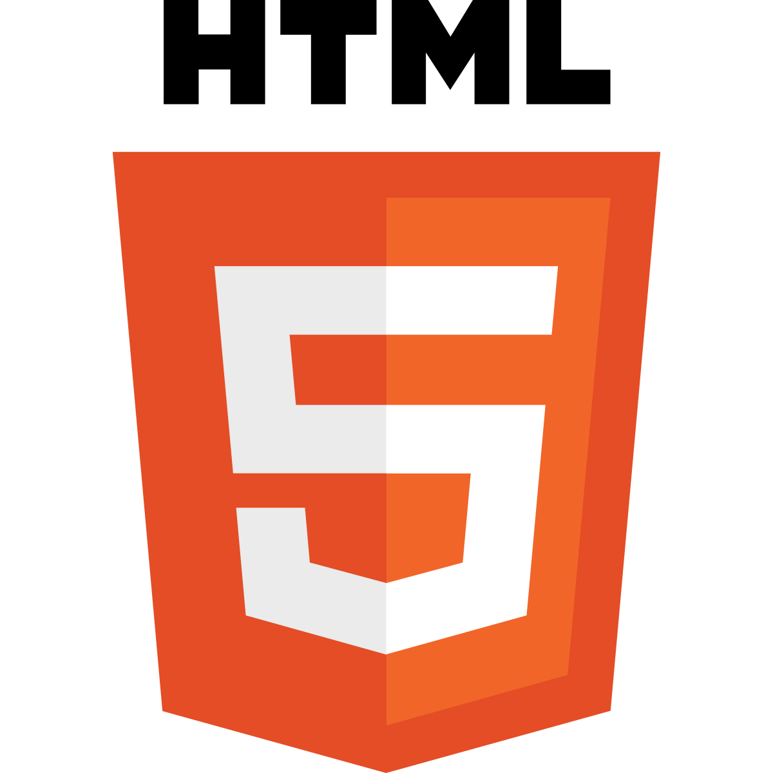

In 1980, physicist [Tim Berners-Lee](https://en.wikipedia.org/wiki/Tim_Berners-Lee), a contractor at [CERN](https://en.wikipedia.org/wiki/CERN), proposed and prototyped [ENQUIRE](https://en.wikipedia.org/wiki/ENQUIRE), a system for CERN researchers to use and share documents. In 1989, Berners-Lee wrote a memo proposing an [Internet](https://en.wikipedia.org/wiki/Internet)-based [hypertext](https://en.wikipedia.org/wiki/Hypertext) system.[[3]](https://en.wikipedia.org/wiki/HTML#cite_note-3) Berners-Lee specified HTML and wrote the browser and server software in late 1990. That year, Berners-Lee and CERN data systems engineer [Robert Cailliau](https://en.wikipedia.org/wiki/Robert_Cailliau) collaborated on a joint request for funding, but the project was not formally adopted by CERN. In his personal notes[[4]](https://en.wikipedia.org/wiki/HTML#cite_note-4) from 1990 he listed[[5]](https://en.wikipedia.org/wiki/HTML#cite_note-5) "some of the many areas in which hypertext is used" and put an encyclopedia first.

HTML markup consists of several key components, including those called *tags* (and their *attributes*), character-based *data types*, *character references* and *entity references*. HTML tags most commonly come in pairs like <h1> and </h1>, although some represent *empty elements* and so are unpaired, for example <img>. The first tag in such a pair is the *start tag*, and the second is the *end tag* (they are also called *opening tags* and *closing tags*).

Another important component is the HTML [*document type declaration*](https://en.wikipedia.org/wiki/Document_type_declaration), which triggers [standards mode](https://en.wikipedia.org/wiki/Standards_mode) rendering.

The following is an example of the classic ["Hello, World!" program](https://en.wikipedia.org/wiki/%22Hello,_World!%22_program):

<!DOCTYPE html>

<html>

<head>

<title>This is a title</title>

</head>

<body>

<div>

<p>Hello world!</p>

</div>

</body>

</html>

The text between <html> and </html> describes the web page, and the text between <body> and </body> is the visible page content. The markup text <title>This is a title</title> defines the browser page title, and the tag <div> defines a division of the page used for easy styling.

The Document Type Declaration <!DOCTYPE html> is for HTML5. If a declaration is not included, various browsers will revert to "[quirks mode](https://en.wikipedia.org/wiki/Quirks_mode)" for rendering.[[70]](https://en.wikipedia.org/wiki/HTML#cite_note-hsivonen-70)

**AJAX**

**Ajax** (also **AJAX** [/ˈeɪdʒæks/](https://en.wikipedia.org/wiki/Help:IPA/English); short for "Asynchronous [JavaScript](https://en.wikipedia.org/wiki/JavaScript) and [XML](https://en.wikipedia.org/wiki/XML)")[[1]](https://en.wikipedia.org/wiki/Ajax_(programming)#cite_note-garrett-1)[[2]](https://en.wikipedia.org/wiki/Ajax_(programming)#cite_note-2) is a set of [web development](https://en.wikipedia.org/wiki/Web_development) techniques using many web technologies on the [client side](https://en.wikipedia.org/wiki/Client_side) to create [asynchronous](https://en.wikipedia.org/wiki/Asynchronous_I/O) [web applications](https://en.wikipedia.org/wiki/Web_application). With Ajax, web applications can send and retrieve data from a [server](https://en.wikipedia.org/wiki/Web_server) asynchronously (in the background) without interfering with the display and behaviour of the existing page. By decoupling the data interchange layer from the presentation layer, Ajax allows web pages and, by extension, web applications, to change content dynamically without the need to reload the entire page.[[3]](https://en.wikipedia.org/wiki/Ajax_(programming)#cite_note-wrox-3) In practice, modern implementations commonly utilize [JSON](https://en.wikipedia.org/wiki/JSON) instead of XML.

Ajax is not a single technology, but rather a group of technologies. [HTML](https://en.wikipedia.org/wiki/Hypertext_Markup_Language) and [CSS](https://en.wikipedia.org/wiki/Cascading_Style_Sheets) can be used in combination to mark up and style information. The webpage can then be modified by JavaScript to dynamically display—and allow the user to interact with—the new information. The built-in [XMLHttpRequest](https://en.wikipedia.org/wiki/XMLHttpRequest) object, or since 2017 the new "fetch()" function within JavaScript, is commonly used to execute Ajax on webpages, allowing websites to load content onto the screen without refreshing the page. Ajax is not a new technology, or different language, just existing technologies used in new ways.

n the early-to-mid 1990s, most [Web](https://en.wikipedia.org/wiki/World_Wide_Web) sites were based on complete HTML pages. Each user action required that a complete new page be loaded from the server. This process was inefficient, as reflected by the user experience: all page content disappeared, then the new page appeared. Each time the browser reloaded a page because of a partial change, all of the content had to be re-sent, even though only some of the information had changed. This placed additional load on the server and made [bandwidth](https://en.wikipedia.org/wiki/Bandwidth_(computing)) a limiting factor on performance.

In 1996, the [iframe](https://en.wikipedia.org/wiki/Iframe#Frames) tag was introduced by [Internet Explorer](https://en.wikipedia.org/wiki/Internet_Explorer); like the [object](https://en.wikipedia.org/wiki/HTML_element#Images_and_objects) element, it can load or fetch content asynchronously. In 1998, the Microsoft [Outlook Web Access](https://en.wikipedia.org/wiki/Outlook_Web_Access) team developed the concept behind the [XMLHttpRequest](https://en.wikipedia.org/wiki/XMLHttpRequest) scripting object.[[4]](https://en.wikipedia.org/wiki/Ajax_(programming)#cite_note-ALEXHOPMANN-4) It appeared as XMLHTTP in the second version of the [MSXML](https://en.wikipedia.org/wiki/MSXML) library,[[4]](https://en.wikipedia.org/wiki/Ajax_(programming)#cite_note-ALEXHOPMANN-4)[[5]](https://en.wikipedia.org/wiki/Ajax_(programming)#cite_note-MSDN1-5) which shipped with [Internet Explorer 5.0](https://en.wikipedia.org/wiki/Internet_Explorer_5.0) in March 1999.[[6]](https://en.wikipedia.org/wiki/Ajax_(programming)#cite_note-Dutta-6)

The functionality of the Windows XMLHTTP [ActiveX](https://en.wikipedia.org/wiki/ActiveX) control in IE 5 was later implemented by [Mozilla](https://en.wikipedia.org/wiki/Mozilla), [Safari](https://en.wikipedia.org/wiki/Safari_(web_browser)), [Opera](https://en.wikipedia.org/wiki/Opera_(web_browser)) and other browsers as the XMLHttpRequest [JavaScript](https://en.wikipedia.org/wiki/JavaScript) object.[[7]](https://en.wikipedia.org/wiki/Ajax_(programming)#cite_note-apple-7) Microsoft adopted the native XMLHttpRequest model as of [Internet Explorer 7](https://en.wikipedia.org/wiki/Internet_Explorer_7). The ActiveX version is still supported in Internet Explorer, but not in [Microsoft Edge](https://en.wikipedia.org/wiki/Microsoft_Edge). The utility of these background [HTTP](https://en.wikipedia.org/wiki/HTTP) requests and asynchronous Web technologies remained fairly obscure until it started appearing in large scale online applications such as Outlook Web Access (2000)[[8]](https://en.wikipedia.org/wiki/Ajax_(programming)#cite_note-8) and [Oddpost](https://en.wikipedia.org/wiki/Oddpost) (2002).

[Google](https://en.wikipedia.org/wiki/Google) made a wide deployment of standards-compliant, [cross browser](https://en.wikipedia.org/wiki/Cross_browser) Ajax with [Gmail](https://en.wikipedia.org/wiki/Gmail) (2004) and [Google Maps](https://en.wikipedia.org/wiki/Google_Maps) (2005).[[9]](https://en.wikipedia.org/wiki/Ajax_(programming)#cite_note-xhr-history-9) In October 2004 [Kayak.com](https://en.wikipedia.org/wiki/Kayak.com)'s public beta release was among the first large-scale e-commerce uses of what their developers at that time called "the xml http thing".[[10]](https://en.wikipedia.org/wiki/Ajax_(programming)#cite_note-10) This increased interest in AJAX among web program developers.

The term *AJAX* was publicly used on 18 February 2005 by [Jesse James Garrett](https://en.wikipedia.org/wiki/Jesse_James_Garrett) in an article titled *Ajax: A New Approach to Web Applications*, based on techniques used on Google pages.[[1]](https://en.wikipedia.org/wiki/Ajax_(programming)#cite_note-garrett-1)

On 5 April 2006, the [World Wide Web Consortium](https://en.wikipedia.org/wiki/World_Wide_Web_Consortium) (W3C) released the first draft specification for the XMLHttpRequest object in an attempt to create an official [Web standard](https://en.wikipedia.org/wiki/Web_standard).[[11]](https://en.wikipedia.org/wiki/Ajax_(programming)#cite_note-xhr-standard-11) The latest draft of the XMLHttpRequest object was published on 6 October 2016,[[12]](https://en.wikipedia.org/wiki/Ajax_(programming)#cite_note-12) and the XMLHttpRequest specification is now a [living standard](https://en.wikipedia.org/wiki/Living_document).[[13]](https://en.wikipedia.org/wiki/Ajax_(programming)#cite_note-13)

The term *Ajax* has come to represent a broad group of Web technologies that can be used to implement a Web application that communicates with a server in the background, without interfering with the current state of the page. In the article that coined the term Ajax,[[1]](https://en.wikipedia.org/wiki/Ajax_(programming)#cite_note-garrett-1)[[3]](https://en.wikipedia.org/wiki/Ajax_(programming)#cite_note-wrox-3) Jesse James Garrett explained that the following technologies are incorporated:

* [HTML](https://en.wikipedia.org/wiki/HTML) (or [XHTML](https://en.wikipedia.org/wiki/XHTML)) and [CSS](https://en.wikipedia.org/wiki/CSS) for presentation
* The [Document Object Model](https://en.wikipedia.org/wiki/Document_Object_Model) (DOM) for dynamic display of and interaction with data
* [JSON](https://en.wikipedia.org/wiki/JSON) or [XML](https://en.wikipedia.org/wiki/XML) for the interchange of data, and [XSLT](https://en.wikipedia.org/wiki/XSLT) for XML manipulation
* The [XMLHttpRequest](https://en.wikipedia.org/wiki/XMLHttpRequest) object for asynchronous communication
* [JavaScript](https://en.wikipedia.org/wiki/JavaScript) to bring these technologies together

Since then, however, there have been a number of developments in the technologies used in an Ajax application, and in the definition of the term Ajax itself. XML is no longer required for data interchange and, therefore, XSLT is no longer required for the manipulation of data. [JavaScript Object Notation](https://en.wikipedia.org/wiki/JSON) (JSON) is often used as an alternative format for data interchange,[[14]](https://en.wikipedia.org/wiki/Ajax_(programming)#cite_note-tapestry-14) although other formats such as preformatted HTML or plain text can also be used.[[15]](https://en.wikipedia.org/wiki/Ajax_(programming)#cite_note-devx-json-15) A variety of popular JavaScript libraries, including JQuery, include abstractions to assist in executing Ajax requests.

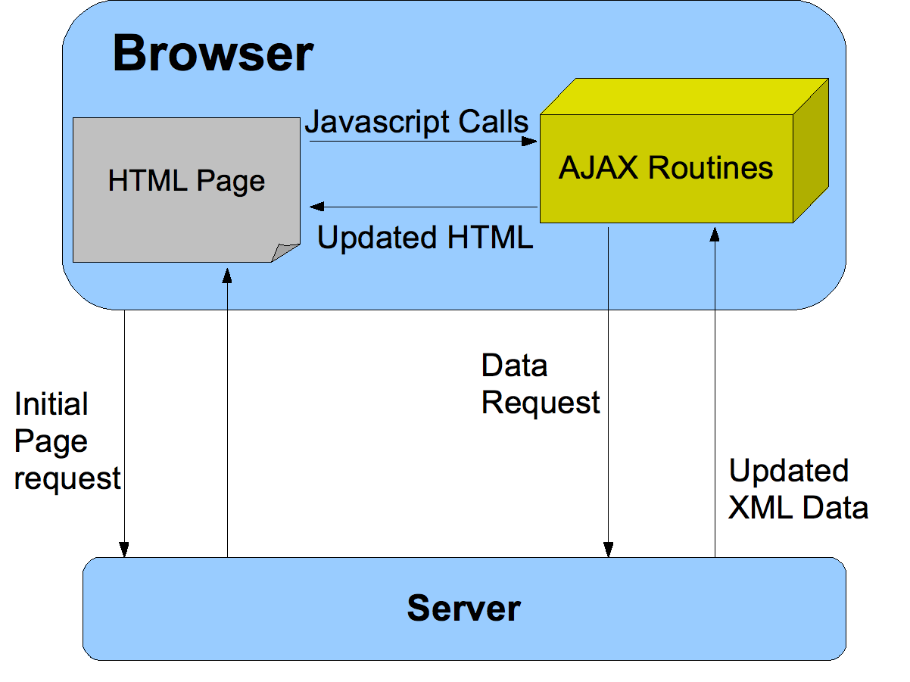



**CSS**

**Cascading Style Sheets** (**CSS**) is a [style sheet language](https://en.wikipedia.org/wiki/Style_sheet_language) used for describing the [presentation](https://en.wikipedia.org/wiki/Presentation_semantics) of a document written in a [markup language](https://en.wikipedia.org/wiki/Markup_language) such as [HTML](https://en.wikipedia.org/wiki/HTML).[[1]](https://en.wikipedia.org/wiki/CSS#cite_note-1) CSS is a cornerstone technology of the [World Wide Web](https://en.wikipedia.org/wiki/World_Wide_Web), alongside HTML and [JavaScript](https://en.wikipedia.org/wiki/JavaScript).[[2]](https://en.wikipedia.org/wiki/CSS#cite_note-2)

CSS is designed to enable the separation of presentation and content, including [layout](https://en.wikipedia.org/wiki/Page_layout), [colors](https://en.wikipedia.org/wiki/Color), and [fonts](https://en.wikipedia.org/wiki/Typeface).[[3]](https://en.wikipedia.org/wiki/CSS#cite_note-3) This separation can improve content [accessibility](https://en.wikipedia.org/wiki/Accessibility), provide more flexibility and control in the specification of presentation characteristics, enable multiple [web pages](https://en.wikipedia.org/wiki/Web_page) to share formatting by specifying the relevant CSS in a separate .css file which reduces complexity and repetition in the structural content as well as enabling the .css file to be [cached](https://en.wikipedia.org/wiki/Cache_(computing)) to improve the page load speed between the pages that share the file and its formatting.

Separation of formatting and content also makes it feasible to present the same markup page in different styles for different rendering methods, such as on-screen, in print, by voice (via speech-based browser or [screen reader](https://en.wikipedia.org/wiki/Screen_reader)), and on [Braille-based](https://en.wikipedia.org/wiki/Braille_display) tactile devices. CSS also has rules for alternate formatting if the content is accessed on a [mobile device](https://en.wikipedia.org/wiki/Mobile_device).[[4]](https://en.wikipedia.org/wiki/CSS#cite_note-4)

The name *cascading* comes from the specified priority scheme to determine which style rule applies if more than one rule matches a particular element. This cascading priority scheme is predictable.

The CSS specifications are maintained by the [World Wide Web Consortium](https://en.wikipedia.org/wiki/World_Wide_Web_Consortium) (W3C). Internet media type ([MIME type](https://en.wikipedia.org/wiki/MIME_media_type)) text/css is registered for use with CSS by [RFC 2318](https://tools.ietf.org/html/rfc2318) (March 1998). The W3C operates a free [CSS validation service](https://en.wikipedia.org/wiki/W3C_Markup_Validation_Service#CSS_validation) for CSS documents.[[5]](https://en.wikipedia.org/wiki/CSS#cite_note-5)

In addition to HTML, other markup languages support the use of CSS including [XHTML](https://en.wikipedia.org/wiki/XHTML), [plain XML](https://en.wikipedia.org/wiki/Plain_Old_XML), [SVG](https://en.wikipedia.org/wiki/Scalable_Vector_Graphics), and [XUL](https://en.wikipedia.org/wiki/XUL).

Before CSS, nearly all presentational attributes of HTML documents were contained within the HTML markup. All font colors, background styles, element alignments, borders and sizes had to be explicitly described, often repeatedly, within the HTML. CSS lets authors move much of that information to another file, the style sheet, resulting in considerably simpler HTML.

For example, headings (h1 elements), sub-headings (h2), sub-sub-headings (h3), etc., are defined structurally using HTML. In print and on the screen, choice of [font](https://en.wikipedia.org/wiki/Typeface), [size](https://en.wikipedia.org/wiki/Point_(typography)), [color](https://en.wikipedia.org/wiki/Color) and [emphasis](https://en.wikipedia.org/wiki/Emphasis_(typography)) for these elements is *presentational*.

Before CSS, document authors who wanted to assign such [typographic](https://en.wikipedia.org/wiki/Typography) characteristics to, say, all h2 headings had to repeat HTML presentational markup for each occurrence of that heading type. This made documents more complex, larger, and more error-prone and difficult to maintain. CSS allows the separation of presentation from structure. CSS can define color, font, text alignment, size, borders, spacing, layout and many other typographic characteristics, and can do so independently for on-screen and printed views. CSS also defines non-visual styles, such as reading speed and emphasis for aural text readers. The [W3C](https://en.wikipedia.org/wiki/W3C) has now [deprecated](https://en.wikipedia.org/wiki/Deprecation) the use of all presentational HTML markup.[[15]](https://en.wikipedia.org/wiki/CSS#cite_note-15)



For example, under pre-CSS HTML, a heading element defined with red text would be written as:

<h1><font color="red">Chapter 1.</font></h1>

Using CSS, the same element can be coded using style properties instead of HTML presentational attributes:

<h1 style="color: red;">Chapter 1.</h1>

The advantages of this may not be immediately clear but the power of CSS becomes more apparent when the style properties are placed in an internal style element or, even better, an external CSS file. For example, suppose the document contains the style element:

<style>

h1 {

color: red;

}

</style>

All h1 elements in the document will then automatically become red without requiring any explicit code. If the author later wanted to make h1 elements blue instead, this could be done by changing the style element to:

<style>

h1 {

color: blue;

}

</style>

rather than by laboriously going through the document and changing the color for each individual h1 element.

The styles can also be placed in an external CSS file, as described below, and loaded using syntax similar to:

<link href="path/to/file.css" rel="stylesheet" type="text/css">

This further decouples the styling from the HTML document and makes it possible to restyle multiple documents by simply editing a shared external CSS file.

**JavaScript**

**JavaScript** ([/ˈdʒɑːvəˌskrɪpt/](https://en.wikipedia.org/wiki/Help:IPA/English)),[[6]](https://en.wikipedia.org/wiki/JavaScript#cite_note-6) often abbreviated as **JS**, is a [programming language](https://en.wikipedia.org/wiki/Programming_language) that conforms to the [ECMAScript](https://en.wikipedia.org/wiki/ECMAScript) specification.[[7]](https://en.wikipedia.org/wiki/JavaScript#cite_note-tc39-7) JavaScript is [high-level](https://en.wikipedia.org/wiki/High-level_programming_language), often [just-in-time compiled](https://en.wikipedia.org/wiki/Just-in-time_compilation), and [multi-paradigm](https://en.wikipedia.org/wiki/Programming_paradigm). It has [curly-bracket syntax](https://en.wikipedia.org/wiki/List_of_programming_languages_by_type#Curly-bracket_languages), [dynamic typing](https://en.wikipedia.org/wiki/Dynamic_typing), [prototype-based](https://en.wikipedia.org/wiki/Prototype-based_programming) [object-orientation](https://en.wikipedia.org/wiki/Object-oriented_programming), and [first-class functions](https://en.wikipedia.org/wiki/First-class_function).

Alongside [HTML](https://en.wikipedia.org/wiki/HTML) and [CSS](https://en.wikipedia.org/wiki/CSS), JavaScript is one of the core technologies of the [World Wide Web](https://en.wikipedia.org/wiki/World_Wide_Web).[[8]](https://en.wikipedia.org/wiki/JavaScript#cite_note-8) JavaScript enables interactive [web pages](https://en.wikipedia.org/wiki/Web_page) and is an essential part of [web applications](https://en.wikipedia.org/wiki/Web_application). The vast majority of [websites](https://en.wikipedia.org/wiki/Website) use it for [client-side](https://en.wikipedia.org/wiki/Client-side) page behavior,[[9]](https://en.wikipedia.org/wiki/JavaScript#cite_note-deployedstats-9) and all major [web browsers](https://en.wikipedia.org/wiki/Web_browser) have a dedicated [JavaScript engine](https://en.wikipedia.org/wiki/JavaScript_engine) to execute it.

As a multi-paradigm language, JavaScript supports [event-driven](https://en.wikipedia.org/wiki/Event-driven_programming), [functional](https://en.wikipedia.org/wiki/Functional_programming), and [imperative](https://en.wikipedia.org/wiki/Imperative_programming) [programming styles](https://en.wikipedia.org/wiki/Programming_paradigm). It has [application programming interfaces](https://en.wikipedia.org/wiki/Application_programming_interface) (APIs) for working with text, dates, [regular expressions](https://en.wikipedia.org/wiki/Regular_expression), standard [data structures](https://en.wikipedia.org/wiki/Data_structure), and the [Document Object Model](https://en.wikipedia.org/wiki/Document_Object_Model) (DOM). However, the language itself does not include any [input/output](https://en.wikipedia.org/wiki/Input/output) (I/O), such as [networking](https://en.wikipedia.org/wiki/Computer_network), [storage](https://en.wikipedia.org/wiki/Data_storage), or [graphics](https://en.wikipedia.org/wiki/Computer_graphics) facilities, as the host environment (usually a web browser) provides those APIs.

JavaScript engines were originally used only in web browsers, but they are now embedded in some [servers](https://en.wikipedia.org/wiki/Server_(computing)), usually via [Node.js](https://en.wikipedia.org/wiki/Node.js). They are also embedded in a variety of applications created with [frameworks](https://en.wikipedia.org/wiki/Software_framework) such as [Electron](https://en.wikipedia.org/wiki/Electron_(software_framework)) and [Cordova](https://en.wikipedia.org/wiki/Apache_Cordova).

Although there are similarities between JavaScript and [Java](https://en.wikipedia.org/wiki/Java_(programming_language)), including language name, [syntax](https://en.wikipedia.org/wiki/Syntax_(programming_languages)), and respective [standard libraries](https://en.wikipedia.org/wiki/Standard_library), the two languages are distinct and differ greatly in design.

The use of JavaScript has expanded beyond its [web browser](https://en.wikipedia.org/wiki/Web_browser) roots. [JavaScript engines](https://en.wikipedia.org/wiki/JavaScript_engine) are now embedded in a variety of other software systems, both for [server-side](https://en.wikipedia.org/wiki/Server-side) website deployments and non-browser [applications](https://en.wikipedia.org/wiki/Application_software).

Initial attempts at promoting server-side JavaScript usage were [Netscape Enterprise Server](https://en.wikipedia.org/wiki/Netscape_Enterprise_Server) and [Microsoft](https://en.wikipedia.org/wiki/Microsoft)'s [Internet Information Services](https://en.wikipedia.org/wiki/Internet_Information_Services),[[30]](https://en.wikipedia.org/wiki/JavaScript#cite_note-30)[[31]](https://en.wikipedia.org/wiki/JavaScript#cite_note-31) but they were small niches.[[32]](https://en.wikipedia.org/wiki/JavaScript#cite_note-2009server-32) Server-side usage eventually started to grow in the late-2000s, with the creation of [Node.js](https://en.wikipedia.org/wiki/Node.js) and [other approaches](https://en.wikipedia.org/wiki/List_of_server-side_JavaScript_implementations).[[32]](https://en.wikipedia.org/wiki/JavaScript#cite_note-2009server-32)



[Electron](https://en.wikipedia.org/wiki/Electron_(software_framework)), [Cordova](https://en.wikipedia.org/wiki/Apache_Cordova), and other [software frameworks](https://en.wikipedia.org/wiki/Software_framework) have been used to create many applications with behavior implemented in JavaScript. Other non-browser applications include [Adobe Acrobat](https://en.wikipedia.org/wiki/Adobe_Acrobat) support for scripting [PDF](https://en.wikipedia.org/wiki/PDF) documents[[33]](https://en.wikipedia.org/wiki/JavaScript#cite_note-33) and [GNOME Shell](https://en.wikipedia.org/wiki/GNOME_Shell) extensions written in JavaScript.[[34]](https://en.wikipedia.org/wiki/JavaScript#cite_note-34)

JavaScript has recently begun to appear in some [embedded systems](https://en.wikipedia.org/wiki/Embedded_system), usually by leveraging Node.js.[[35]](https://en.wikipedia.org/wiki/JavaScript#cite_note-35)[[36]](https://en.wikipedia.org/wiki/JavaScript#cite_note-36)[[37]](https://en.wikipedia.org/wiki/JavaScript#cite_note-37)

**DJANGO**

**Django** ([/ˈdʒæŋɡoʊ/](https://en.wikipedia.org/wiki/Help:IPA/English) [*JANG-goh*](https://en.wikipedia.org/wiki/Help:Pronunciation_respelling_key); sometimes stylized as **django**)[[8]](https://en.wikipedia.org/wiki/Django_(web_framework)#cite_note-8) is a [Python](https://en.wikipedia.org/wiki/Python_(programming_language))-based [free and open-source](https://en.wikipedia.org/wiki/Free_and_open-source_software) [web framework](https://en.wikipedia.org/wiki/Web_framework) that follows the model-template-views (MTV) [architectural pattern](https://en.wikipedia.org/wiki/Architectural_pattern_(computer_science)).[[9]](https://en.wikipedia.org/wiki/Django_(web_framework)#cite_note-faq-mvc-9)[[10]](https://en.wikipedia.org/wiki/Django_(web_framework)#cite_note-djangobook-mvc-10) It is maintained by the [Django Software Foundation](https://en.wikipedia.org/wiki/Django_Software_Foundation) (DSF), an American independent organization established as a [501(c)(3)](https://en.wikipedia.org/wiki/501(c)(3)) non-profit.

Django's primary goal is to ease the creation of complex, database-driven websites. The framework emphasizes [reusability](https://en.wikipedia.org/wiki/Reusability) and "pluggability" of components, less code, low coupling, rapid development, and the principle of [don't repeat yourself](https://en.wikipedia.org/wiki/Don%27t_repeat_yourself).[[11]](https://en.wikipedia.org/wiki/Django_(web_framework)#cite_note-11) Python is used throughout, even for settings, files, and data models. Django also provides an optional administrative [create, read, update and delete](https://en.wikipedia.org/wiki/Create,_read,_update_and_delete) interface that is generated dynamically through [introspection](https://en.wikipedia.org/wiki/Type_introspection) and configured via admin models.

Some well known sites that use Django include [PBS](https://en.wikipedia.org/wiki/PBS),[[12]](https://en.wikipedia.org/wiki/Django_(web_framework)#cite_note-20sites-12) [Instagram](https://en.wikipedia.org/wiki/Instagram),[[13]](https://en.wikipedia.org/wiki/Django_(web_framework)#cite_note-13) [Mozilla](https://en.wikipedia.org/wiki/Mozilla_Foundation),[[14]](https://en.wikipedia.org/wiki/Django_(web_framework)#cite_note-14) [*The Washington Times*](https://en.wikipedia.org/wiki/The_Washington_Times),[[15]](https://en.wikipedia.org/wiki/Django_(web_framework)#cite_note-15) [Disqus](https://en.wikipedia.org/wiki/Disqus),[[16]](https://en.wikipedia.org/wiki/Django_(web_framework)#cite_note-16) [Bitbucket](https://en.wikipedia.org/wiki/Bitbucket),[[17]](https://en.wikipedia.org/wiki/Django_(web_framework)#cite_note-17) and [Nextdoor](https://en.wikipedia.org/wiki/Nextdoor).[[18]](https://en.wikipedia.org/wiki/Django_(web_framework)#cite_note-18)

Django was created in the fall of 2003, when the [web programmers](https://en.wikipedia.org/wiki/Web_programmer) at the [*Lawrence Journal-World*](https://en.wikipedia.org/wiki/Lawrence_Journal-World) newspaper, [Adrian Holovaty](https://en.wikipedia.org/wiki/Adrian_Holovaty) and [Simon Willison](https://en.wikipedia.org/wiki/Simon_Willison), began using Python to build applications. [Jacob Kaplan-Moss](https://en.wikipedia.org/w/index.php?title=Jacob_Kaplan-Moss&action=edit&redlink=1) was hired early in Django's development shortly before Simon Willison's internship ended.[[19]](https://en.wikipedia.org/wiki/Django_(web_framework)#cite_note-19) It was released publicly under a [BSD license](https://en.wikipedia.org/wiki/BSD_license) in July 2005. The framework was named after guitarist [Django Reinhardt](https://en.wikipedia.org/wiki/Django_Reinhardt).[[20]](https://en.wikipedia.org/wiki/Django_(web_framework)#cite_note-Django's_History-20)

In June 2008, it was announced that a newly formed [Django Software Foundation](https://en.wikipedia.org/wiki/Django_Software_Foundation) (DSF) would maintain Django in the future.[[21]](https://en.wikipedia.org/wiki/Django_(web_framework)#cite_note-21)



For developing a Django project, no special tools are necessary, since the source code can be edited with any conventional [text editor](https://en.wikipedia.org/wiki/Text_editor). Nevertheless, editors specialized on [computer programming](https://en.wikipedia.org/wiki/Computer_programming) can help increase the productivity of development, e.g., with features such as [syntax highlighting](https://en.wikipedia.org/wiki/Syntax_highlighting). Since Django is written in Python, text editors which are aware of Python syntax are beneficial in this regard.

[Integrated development environments](https://en.wikipedia.org/wiki/Integrated_development_environment) (IDE) add further functionality, such as [debugging](https://en.wikipedia.org/wiki/Debugging), [refactoring](https://en.wikipedia.org/wiki/Code_refactoring), and [unit testing](https://en.wikipedia.org/wiki/Unit_testing). As with plain editors, IDEs with support for Python can be beneficial. Some IDEs that are specialized on Python additionally have integrated support for Django projects, so that using such an IDE when developing a Django project can help further increase productivity. For comparison of such Python IDEs, see the main article:

**Certificates**



**References**

We have used wikipedia, youtube,google,vscode editor,github for creating this project.

Some of useful websites are

<https://docs.djangoproject.com/>

<https://github.com/>

<https://www.google.com/>

<https://www.youtube.com/>